

Smart Tax Payment Tracking System

**Course Name:** Database Systems

**Instructor:** Professor Xiaofeng Li

ABHINAV REDDY KALLEM

**#Connect Database**

In our project, I utilized the Python Flask framework to build an instance called app.py, and then connected to our database using the Sqlite. I have set SQLALCHEMY_DATABASE_URI as 'sqlite:///TaxTracker.db. A connection is established between the db and the app. I made the db and migration object from the app, after the database is created. And then, I built the TaxPayment model with six columns where t_id is the primary key.

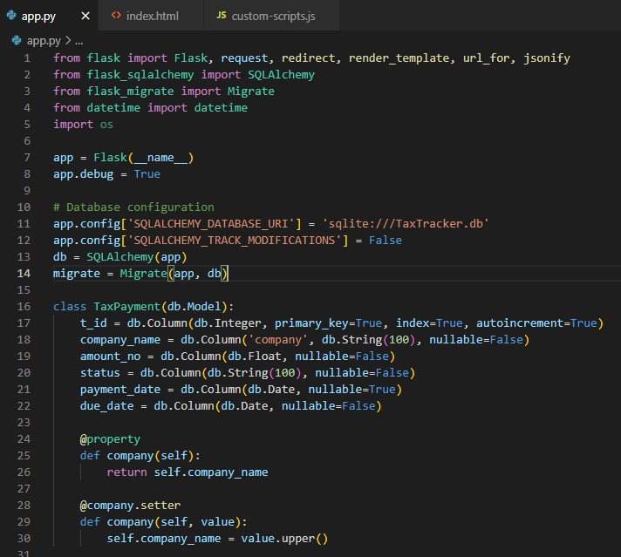

After that, I have created a route for showing the home page of the app. And then I created a route to get the tax payment records based on a specific due date.

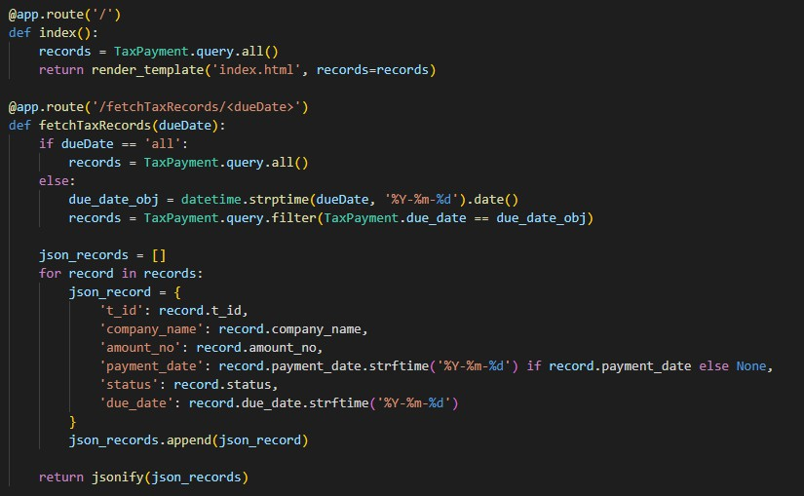

Then I created another route to insert a new record

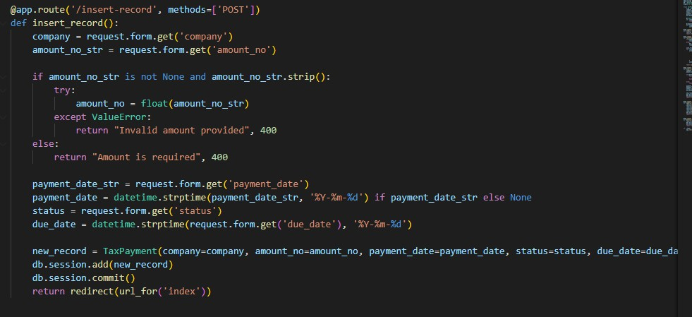

After that, I created another route to update any existing record. Then I create a route to delete any existing records.

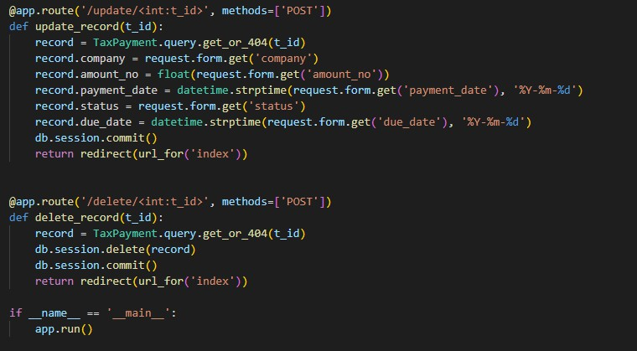

**API and Controller:**

ENDPOINT ‘/’ (only controller) METHOD: GET

ENDPOINT ‘/fetch/TaxRecords/<dueDate>’

ENDPOINT ‘/insert-record’ METHOD: POST

ENDPOINT: ‘/update/<int:t_id>’ METHOD: POST

ENDPOINT: ‘delete/<int:t_id>’ METHOD: POST

**Index.html Code:**

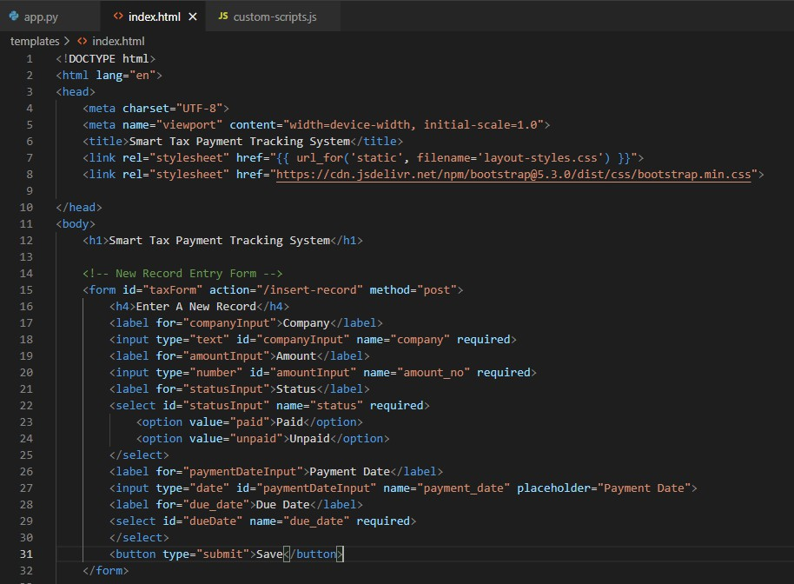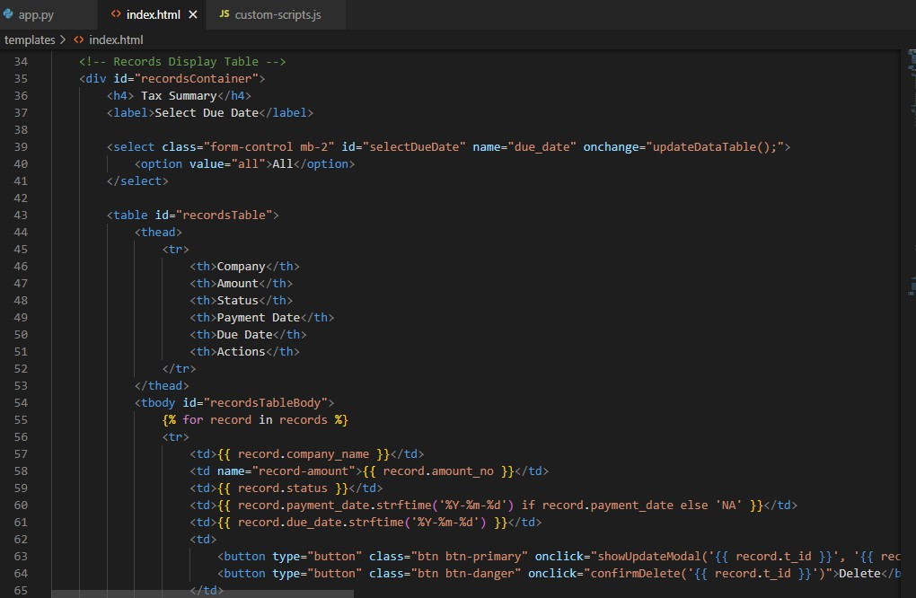

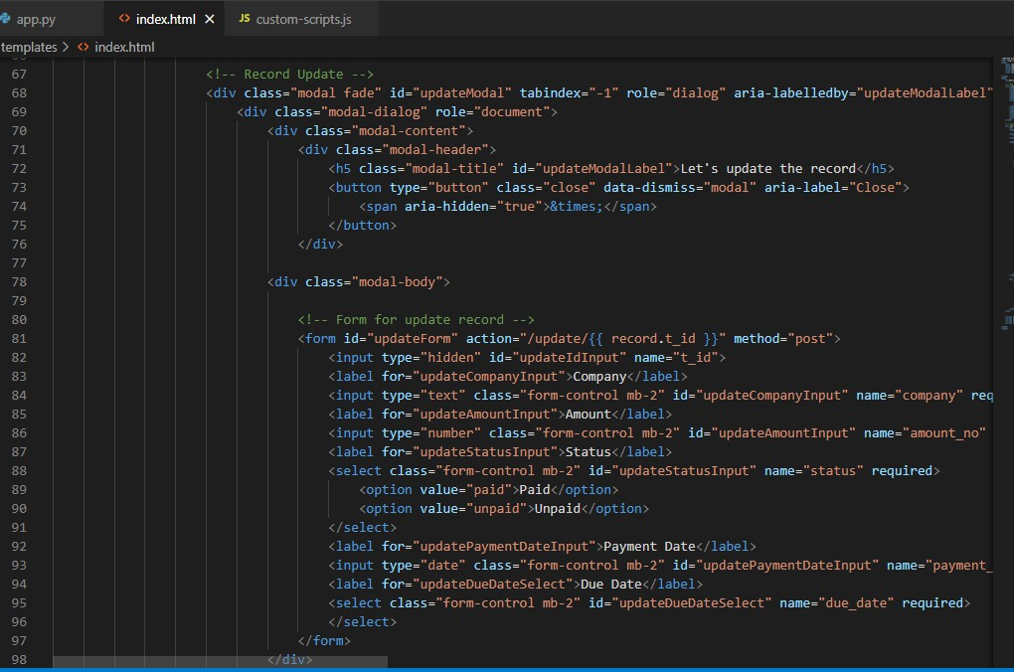

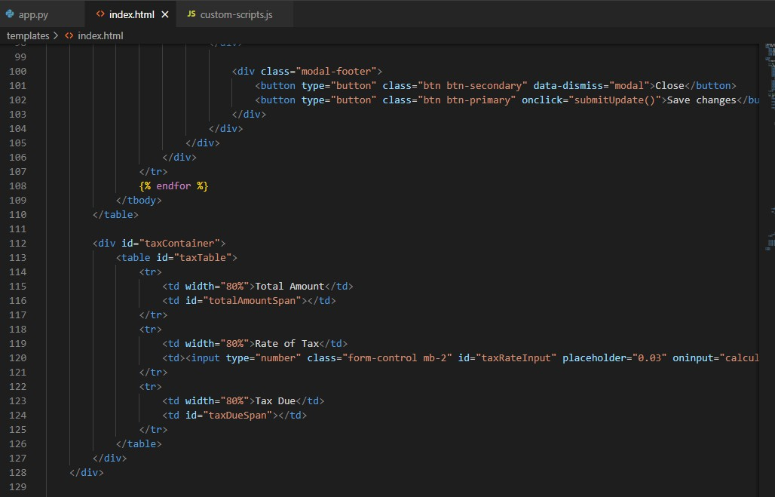

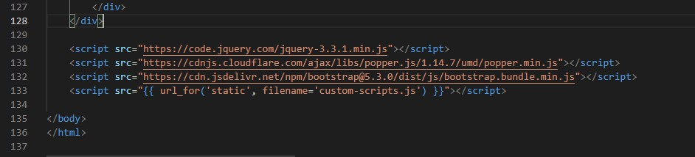

**layout-styles.css**

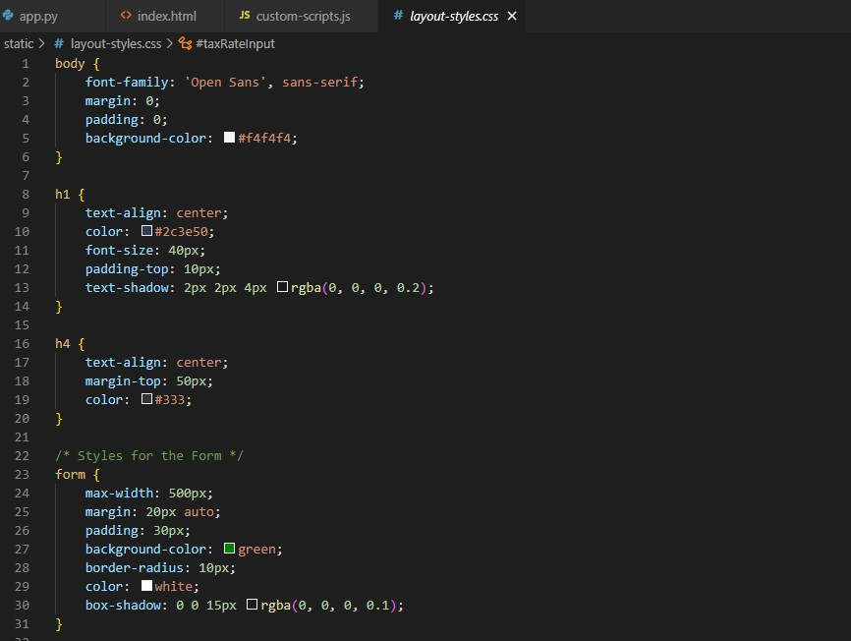

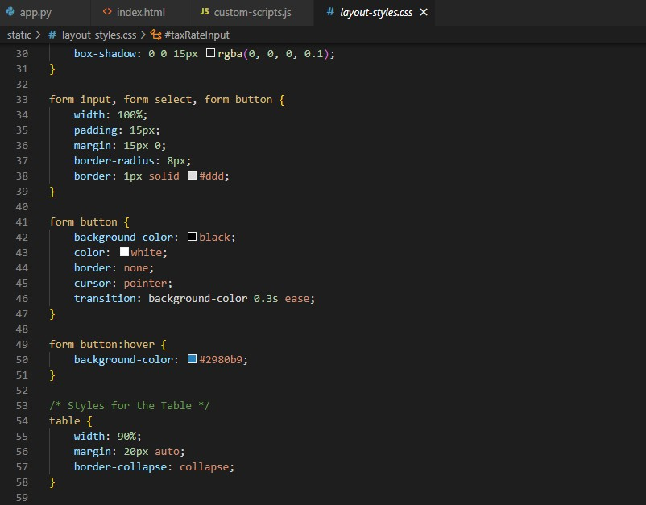

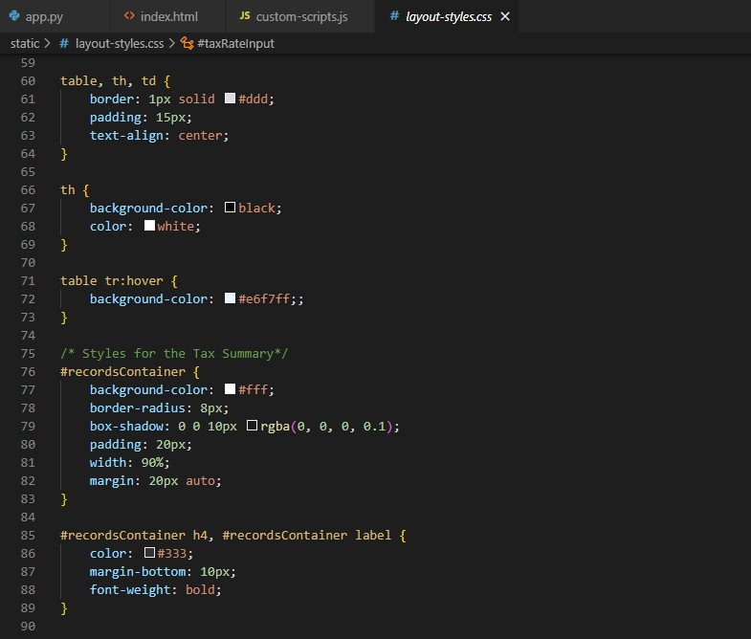

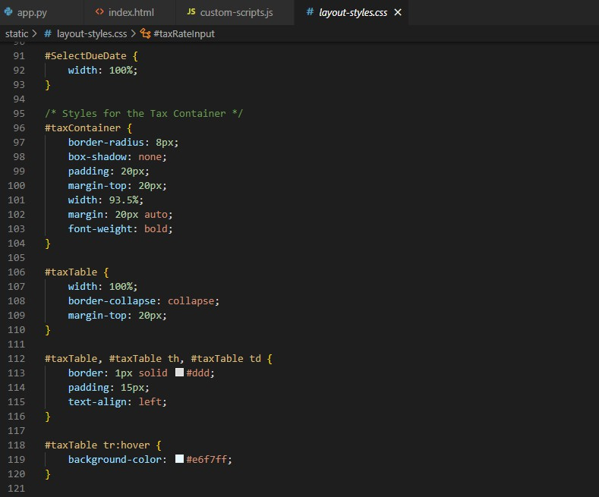

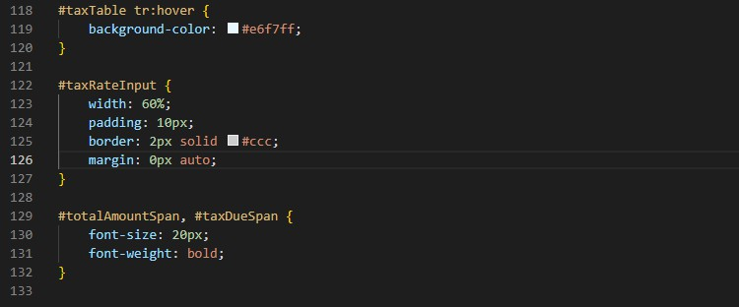

**custom-scripts.js**

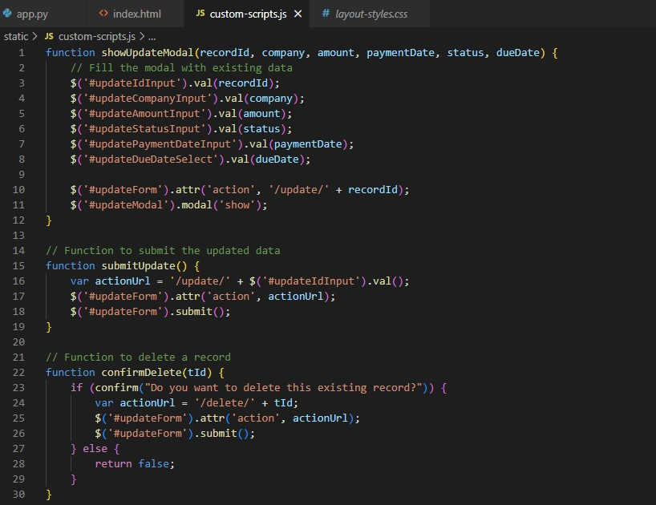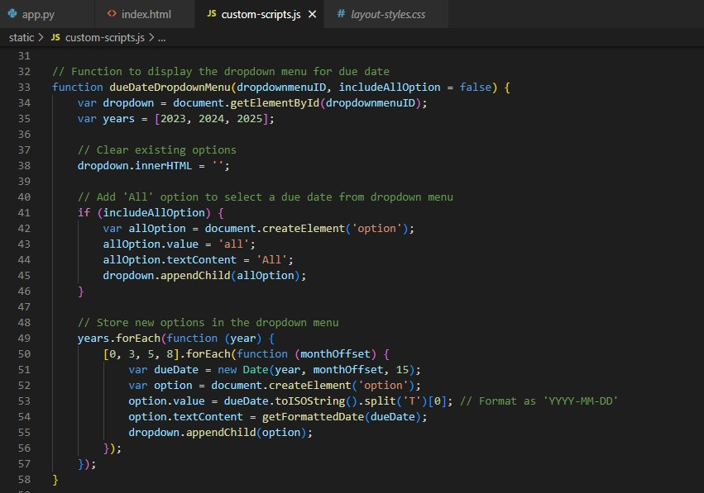

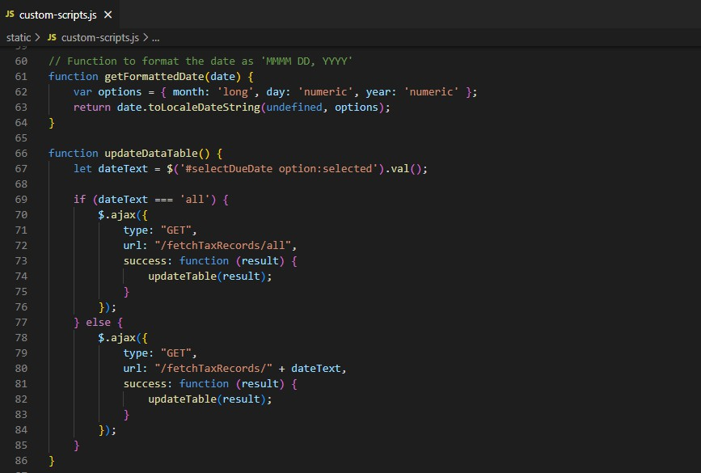

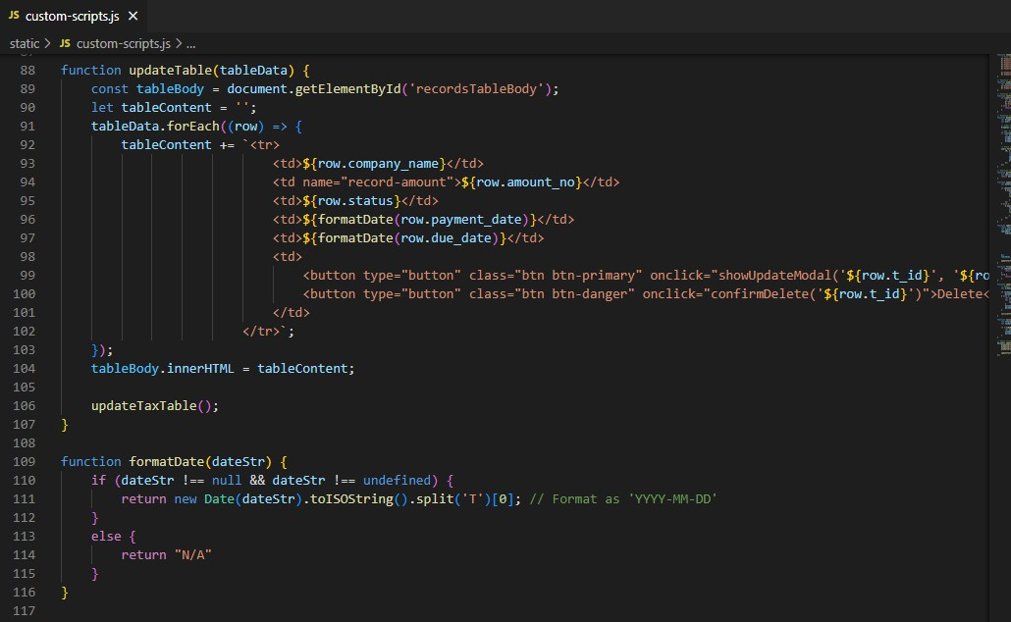

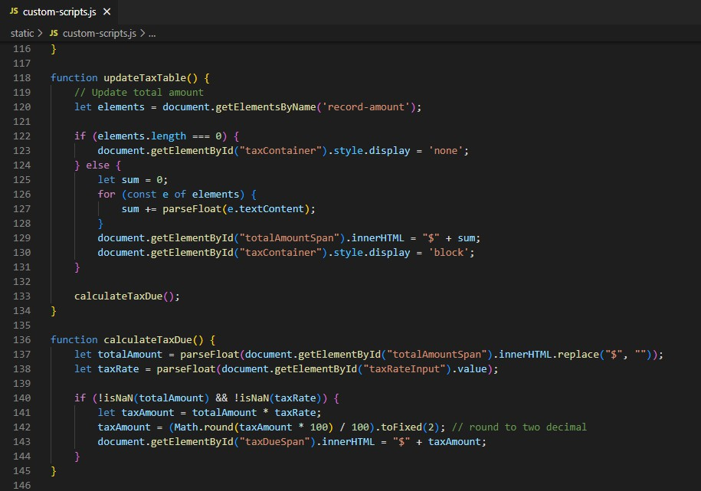

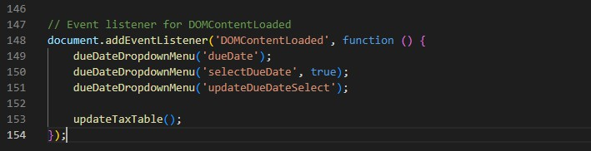

**Screenshot of Project:**

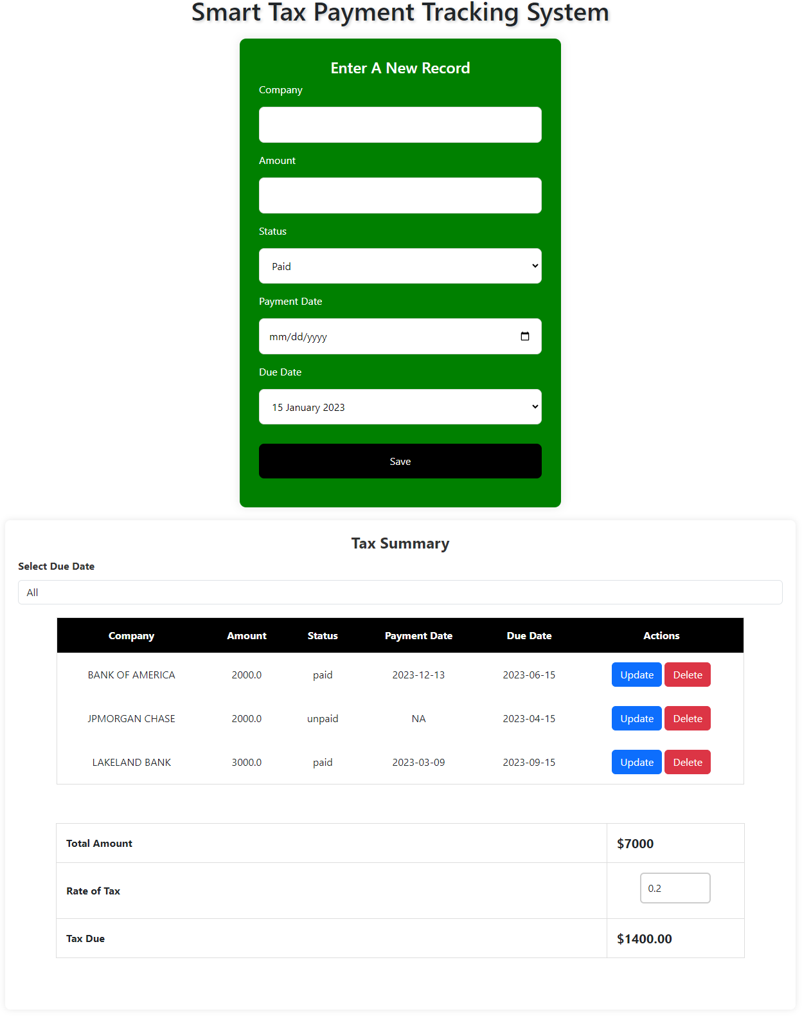

**For any specific due date:**

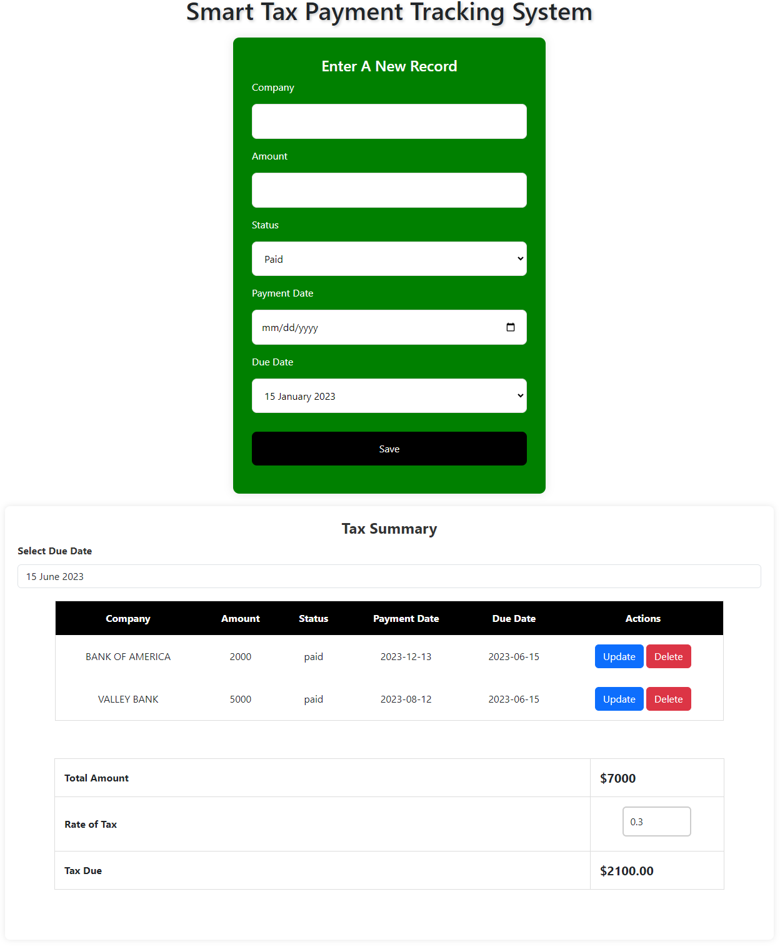

**GitHub Repository:**